1. Subversion revision r73 date: 02/18/2024 3:41:13 PM

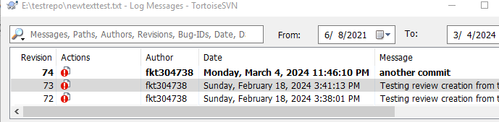

1. R73 revision date in Collaborator review 1023 is 02/18/2024 14:41 – this is wrong

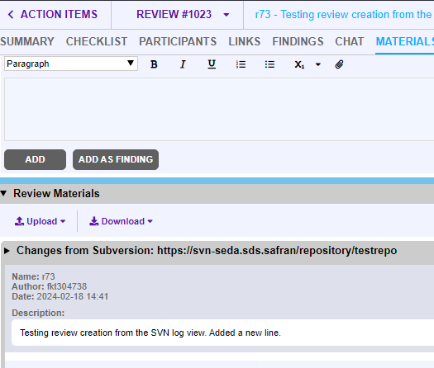

1. R73 revision date in Collaborator review screen is 1989-12-31 16:00 and r72 is also one hour off.

